
August 27, 2026

TO: Prospective Bidders

FROM: Reynold Lee, Land Agent
Department of Land and Natural Resources, Land Division

SUBJECT: Provide and erect 4” thick galvanized pole and concrete base for support. A 20’ Long Pole with at least 15’ above ground. (Two (2) total poles in two (2) different locations). Provide a 6” deep x 6” wide trench from the pole foundation to the waterline.

- Puu Lua Reservoir, Waimea Canyon Park, Kokee, Kauai, Tax Map Key: (4) 1-4-001:002. GPS location coordinates approximately 22.08865, -159.67811 (1 galvanized pole)

- Lower Kapahi Reservoir, Kawaihau, Kapaa, Kauai, Tax Map Key: (4) 4-6-006: 007. GPS location coordinates approximately 22.100939, -159.352533 (1 galvanized pole)

Please submit a quotation for two (2) locations to: Trench and erect 4” thick galvanized pole and concrete support base. Minimum 20’ Poles with a minimum of 15’ above ground.

Puu Lua Reservoir, Waimea Canyon Park, Kokee, Kauai, Tax Map Key: (4) 1-4-001:002,

and Lower Kapahi Reservoir, Kawaihau, Kapaa, Kauai, Tax Map Key: (4) 4-6-006: 007.

Please submit your fee quote online by 2;00 pm on September 10, 2026, to qualify as a prospective bidder for this project.

Vendor compliance will be conducted via Hawaii Compliance Express (HCE). Compliance is required from the successful bidder prior to awarding project and commencement of work activities. It is the responsibility of the vendor to ensure they are registered with HCE and their information is updated and accurate.

Should you have any questions, please contact Reynold Lee at (808) 274-3491 or email at Reynold.km.lee@hawaii.gov

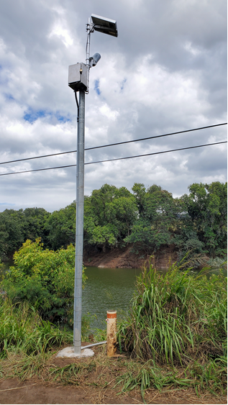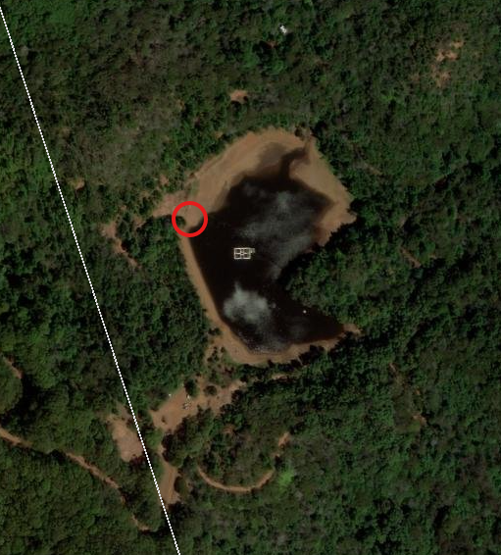
This is sample picture of pole and gauges. Approximate area of GPS coordinates given for Puu Lua.

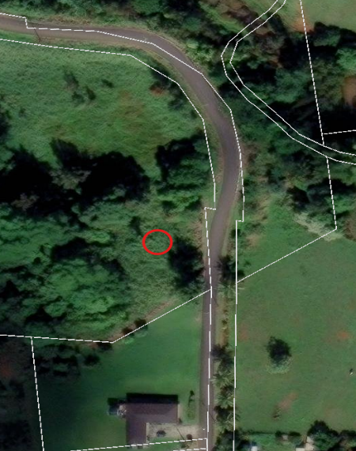
Approximate area of GPS coordinates for Lower Kapahi Reservoir.

